

**PRIVATE HIGHER SCHOOL OF TECHNOLOGY & ENGINEERING**

**REPUBLIC OF TUNISIA Ministry of Higher Education and Scientific Research**

**Computer Engineering Training Program for Engineers**

**BI-ML Project Report**

**Prediction of Fake Reservations for British Airways**

**Made By**

TORKHANI Oumayma

KHALED Ghassen

BEN HMIDA Mohammad Ali

TOKOGMON Djavph David

**Academic Year :** 2022/2023

**Table of Contents**

Contents

Introduction 5

Chapter 1: Introduction 6

1.1 Background 7

1.2 Objectives 7

1.3 Problem Statement 7

1.4 Web Scraping and Dataset 7

1.5 Scrum Methodology 8

1.6 GitHub 12

1.7 CRISP-DM for Machine Learning 14

1.8 Conclusion 15

Chapter 2: Business Intelligence (BI) 16

2.1 Definition and Quick Differentiation of BI 16

2.2 Data Source 16

2.3 Data Preparation 17

2.4 Creating Database Objects 17

2.4.1 ETL Source to Staging 17

2.4.2 ETL Staging to DW 18

2.5 Semantic Layer 21

2.5.1 SSIS Tabular and Multidimensional 21

2.5.1 SSMS Cube 22

2.6 Creating Power BI Report 22

2.7 Conclusion 24

Chapter 3: Machine learning (ML) 25

3.1 Definition and Quick Differentiation of ML 25

3.2 Steps for Developing a Machine Learning Model 25

3.2.1 Business understanding 25

3.2.2 Data understanding 25

3.2.3 Data preparation 26

3.2.4 Modeling 29

3.2.5 Evaluation 30

3.2.6 Deployment 31

3.3 Conclusion 31

Chapter 4: Deployment 32

4.1 Definition and Quick Differentiation of ML Deployment 32

4.2 Django 32

4.3 Web Application with Django 32

4.5 ML Model - Deployment 34

4.6 Conclusion 38

Conclusion 39

**List of Figures**

Figure 1 Screenshot of Trello page with name of members of group 8

Figure 2 Screenshot of different states 9

Figure 3 Screenshot of Sprints of the project (Report, BI Project, ML Project, deployment) 10

Figure 4 Screenshot of different tasks in Report Sprint. 10

Figure 5 Screenshot of different tasks in BI Sprint. 11

Figure 6 Screenshot of different tasks in ML Sprint. 11

Figure 7 Screenshot of different tasks in deployment Sprint. 12

Figure 8 Screenshot of the first step of sending request to collaborate project code 13

Figure 9 Screenshot of central repository “Fake-reservation-check “ 13

Figure 10 Screenshot of BI Project repository named “Fake-reservation-check-BI“ 14

Figure 11 Screenshot of web and deployement Project repository named “Fake-reservation-check-WEB“ 15

Figure 12 Screenshot of ML Project repository named “Fake-reservation-check-ML“ 15

Figure 13 Screenshot of part of Web Scraping Code 18

Figure 14 Graph explained ETL Source to Staging 18

Figure 15 Screenshot of the flow of charging from csv file to staging table 19

Figure 16 Screenshot of new data base and NEW.Source_datastaging 19

Figure 17 Graph explained ETL staging to Datawarehouse 19

Figure 18 Screenshot of the flow of charging from staging table to Data warehouse 1 20

Figure 19 Screenshot of the flow of charging from staging table to Data warehouse 2 20

Figure 20 Screenshot of the data warehouse 21

Figure 21 Screenshot of new data base and NEW.Dims and NEW.Fact 21

Figure 22 Screenshot of Tabular project using SSIS 22

Figure 23 Screenshot of Cube using SSMS 23

Figure 24 Screenshot of Power BI report 1 24

Figure 25 Screenshot of Power BI report 2 24

Figure 26 Screenshot of Power BI report 3 25

Figure 27 Screenshot of dataset details 27

Figure 28 Code of Encoder function 28

Figure 29 Code of drop categorical columns 28

Figure 30 Code of Creating Label dataframe 28

Figure 31 Code of deleting Label from features dataframe 28

Figure 32 Code of Normalizing the values 29

Figure 33 Code to create the correlation matrix 29

Figure 34 figure of correlation matrix 30

Figure 35 Code of spliting data into test and train data 30

Figure 36 Code of Creation random forest model and the training 31

Figure 37 Code of evaluation score functions 31

Figure 38 Code of testing and evaluating the model 31

Figure 39 Screenshot of Project Architect 33

Figure 40 Screenshot of Login Page 34

Figure 41 Screenshot of Dashboard Admin Page 34

Figure 42 Screenshot of Dashboard simple user Page 35

Figure 43 Code using pickle module to creation our ml_model.plk 35

Figure 44 Code using pickle module to creation our scaler.plk 35

Figure 45 Screenshop of the new files created 36

Figure 46 Screenshot of the Model folder architect 36

Figure 47 Code of model predict function 36

Figure 48 Code of view function predict_reservation code 37

Figure 49 Screenshot of a list of reservations awaiting the application of the model. 37

Figure 50 Screenshot of a list of reservations after the application of the model 38

Figure 51 List of prediction 38

Figure 52 List of prediction in csv file 39

Figure 53 Screenshot of a list of reservations after reset the states 39

**List of Tables**

Table 1 Table of meaning of columns 25

Table 2 Divide the columns into features and labels 26

# Introduction

In the airline industry, fake reservations can cause a lot of problems for both airlines and passengers. To prevent this, we worked on a project to use Business Intelligence techniques to analyze the data of British Airways' reservation system and predict the likelihood of a reservation being fraudulent. By using machine learning and data analysis tools, we were able to collect and analyze data from multiple sources to identify patterns and predict fraudulent behavior. In this project, we focused on the steps of data collection, cleaning, modeling, analysis, and visualization. The insights we gained from this project can help British Airways and other airlines to detect and eliminate fraudulent activities, which will improve the customer experience and increase the trust of their customers in the airline industry.

This report is divided into four parts: Introduction, Business Intelligence, Machine Learning, and Conclusion.

- In the Introduction section, we provide background information on the project and discuss the definitions of machine learning and Business Intelligence.

- The Business Intelligence section focuses on data collection, cleaning, and analysis.

- The Machine Learning section covers the development and evaluation of the machine learning model.

- In the end we will get a Conclusion that summarizes the key findings and provides recommendations for detecting and eliminating fraudulent activities in the airline industry.

# Chapter 1: Introduction

## 1.1 Background

In the airline industry, fake reservations can cause a lot of problems for both airlines and passengers. Fraudulent activities such as fake bookings, invalid credit cards, and identity theft can lead to significant losses for the airlines and inconvenience for the passengers. Therefore, it is crucial for airlines to detect and eliminate fraudulent activities to improve the customer experience and increase customer trust.

## 1.2 Objectives

The main objective of this project is to develop a machine learning model to predict the likelihood of a reservation being fraudulent for British Airways. Specifically, the project aims to:

•Collect and preprocess data from multiple sources

•Develop a machine learning model to classify reservations as fraudulent or legitimate

•Evaluate the performance of the model using appropriate metrics

•Provide insights and recommendations based on the results

## 1.3 Problem Statement

The problem addressed in this project is the need for British Airways to detect and prevent fraudulent activities in their reservation system. The current methods of manual checking and random audits are time-consuming and not efficient enough to detect all fraudulent activities. Therefore, the airline needs an automated system that can analyze data and identify potential fraudulent activities with high accuracy and efficiency.

## 1.4 Web Scraping and Dataset

To collect data for this project, we will use web scraping to extract information from online booking platforms. One example of a website that we can use to obtain our dataset is Expedia.com. We will scrape data such as flight details, passenger information, and booking history. We will also collect additional data from internal sources within British Airways. The collected data will be preprocessed and used to train and evaluate the machine learning model.

## 1.5 Scrum Methodology

Scrum is an agile project management framework that emphasizes collaboration, flexibility, and continuous improvement. In Scrum, the project is divided into short iterations called sprints, which typically last between two to four weeks. During each sprint, the team works on a set of tasks and delivers a potentially shippable product increment. Scrum also emphasizes regular team meetings, including daily stand-up meetings, sprint planning meetings, sprint review meetings, and sprint retrospective meetings. The Scrum framework provides a flexible and iterative approach to project management, which can help teams respond quickly to changing requirements and deliver high-quality products.

In our case we use Trello to manage Tasks.

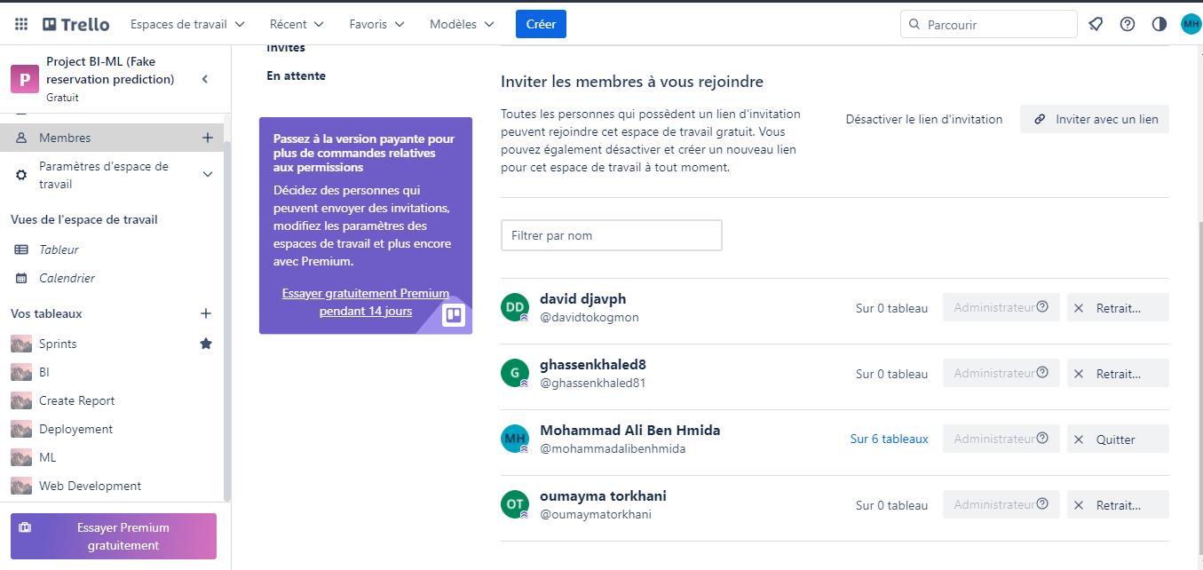

Figure 1 Screenshot of Trello page with name of members of group

For each sprint or task, there are 5 possible states. During our first meeting, we discussed:

**To-do:** Tasks that need to be completed

**In Progress:** Tasks that are currently being worked on

**Done:** Tasks that have been completed

**Questions:** Tasks that require clarification or further information

**To Verify:** Tasks that are completed but need to be checked for accuracy or quality.



Figure 2 Screenshot of different states

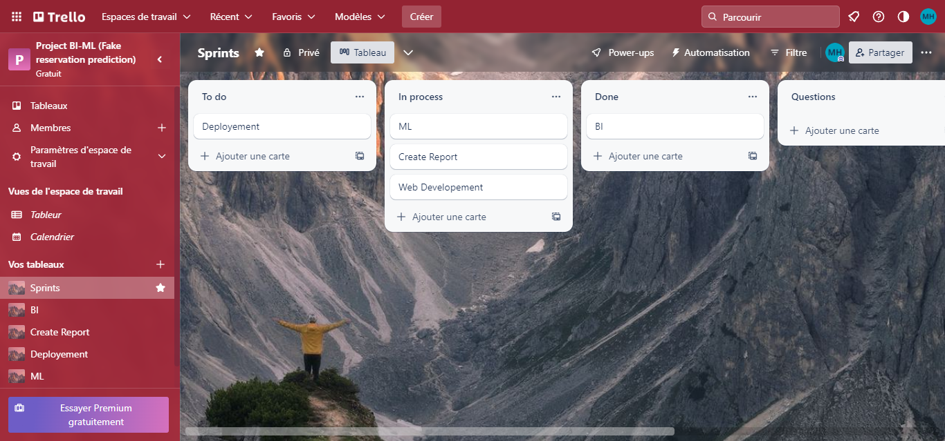

Figure 3 Screenshot of Sprints of the project (Report, BI Project, ML Project, deployment)

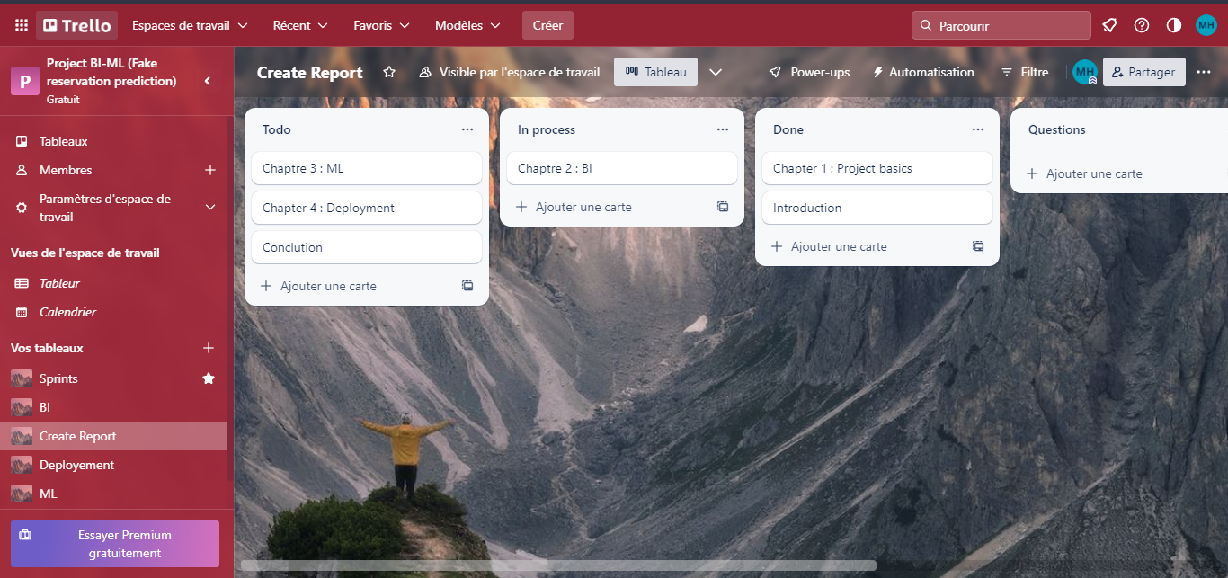

Figure 4 Screenshot of different tasks in Report Sprint.

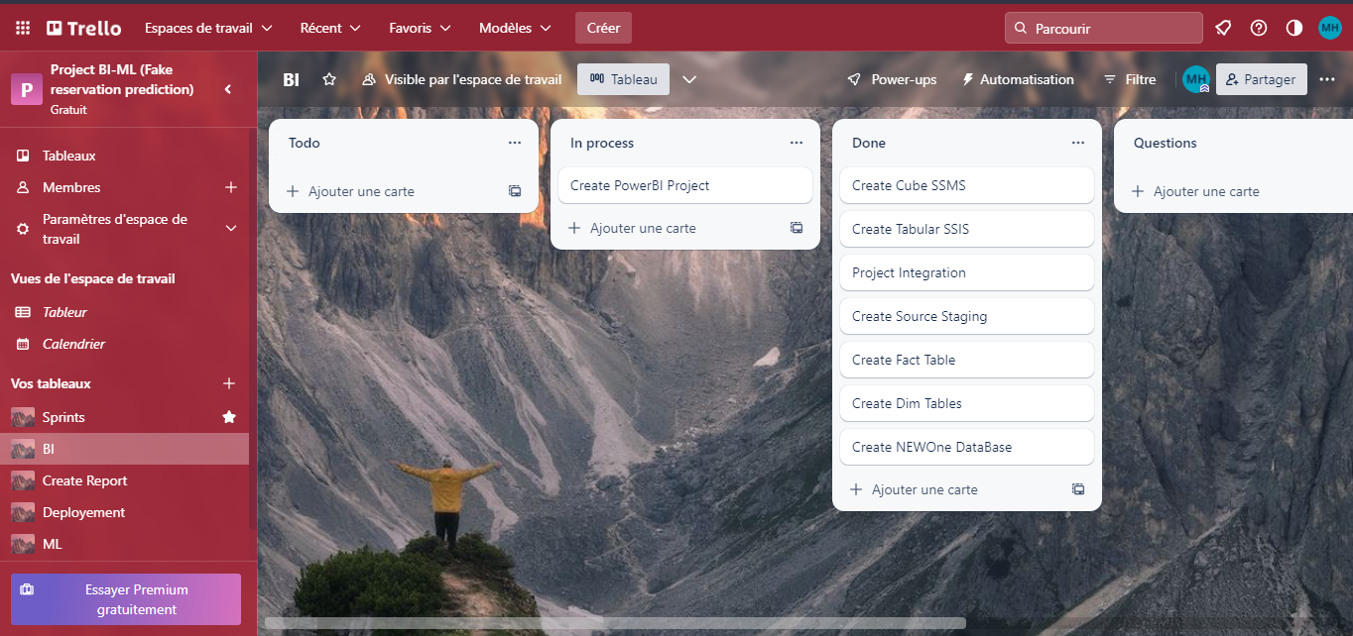

Figure 5 Screenshot of different tasks in BI Sprint.

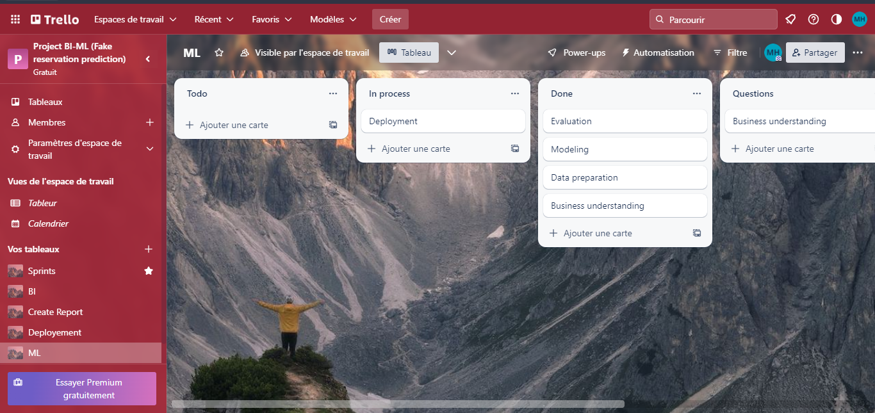

Figure 6 Screenshot of different tasks in ML Sprint.

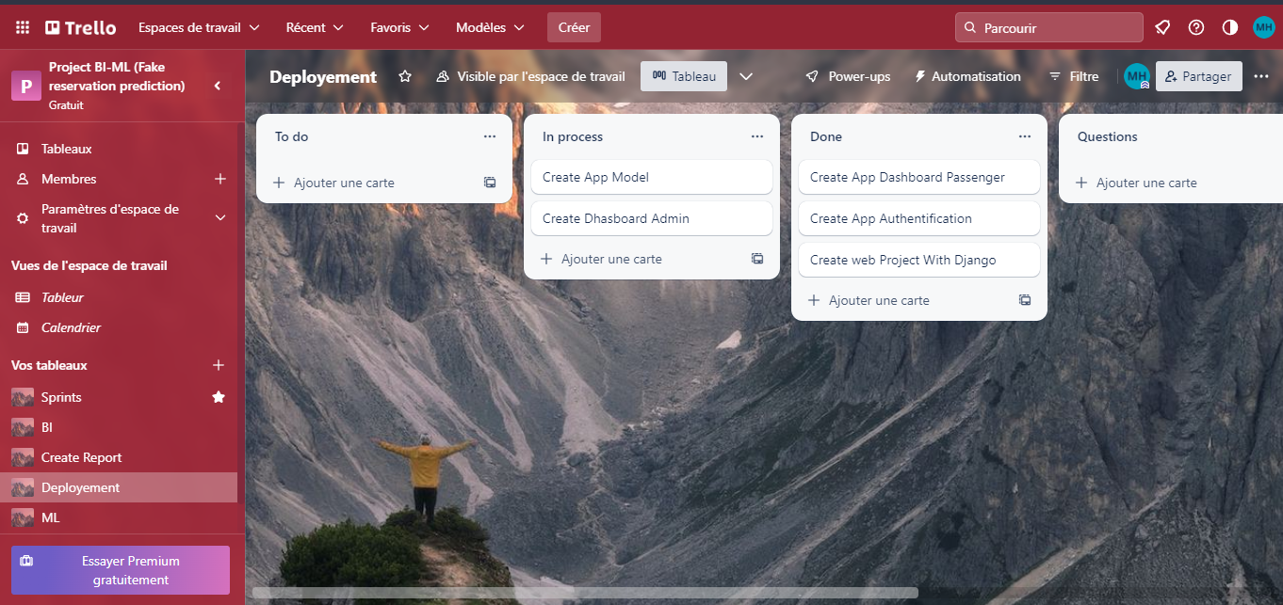

Figure 7 Screenshot of different tasks in deployment Sprint.

## 1.6 GitHub

GitHub is a web-based platform used for version control and collaboration. It allows developers to store and manage their code repositories in a centralized location, making it easy to track changes, collaborate with others.

In our case our repository in GitHub is private and shared between only our group to the best way to manage different parts of project.

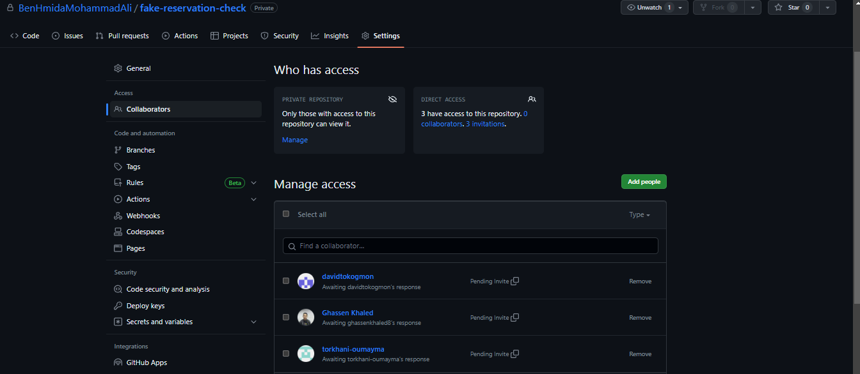

Figure 8 Screenshot of the first step of sending request to collaborate project code

In our specific case, we were working on four different projects: Report, BI, ML, Web, and a deployment project for each one. To streamline our workflow and improve collaboration, we came up with the idea of creating a project called "Fake-reservation-check". This project acts as a central hub, linking all of the other projects together. It makes it easier for our team to manage and keep track of all the code related to the different projects.

(See **figure 9**, **figure 10, figure11** and **figure12**)

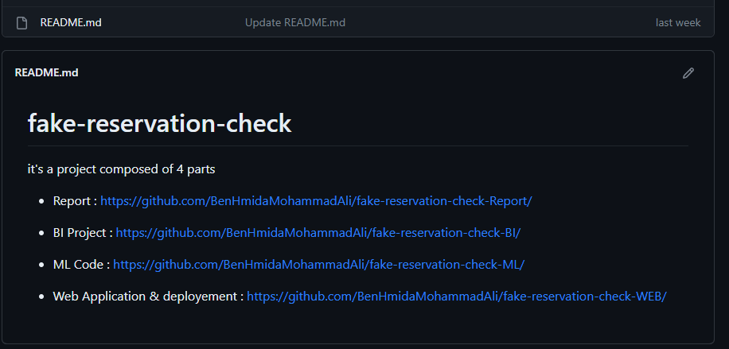

Figure 9 Screenshot of central repository “Fake-reservation-check “

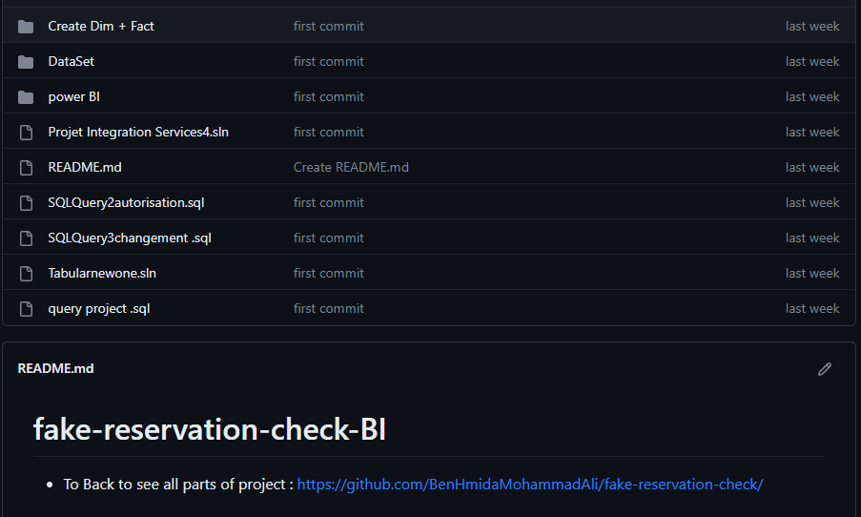

Figure 10 Screenshot of BI Project repository named “Fake-reservation-check-BI“

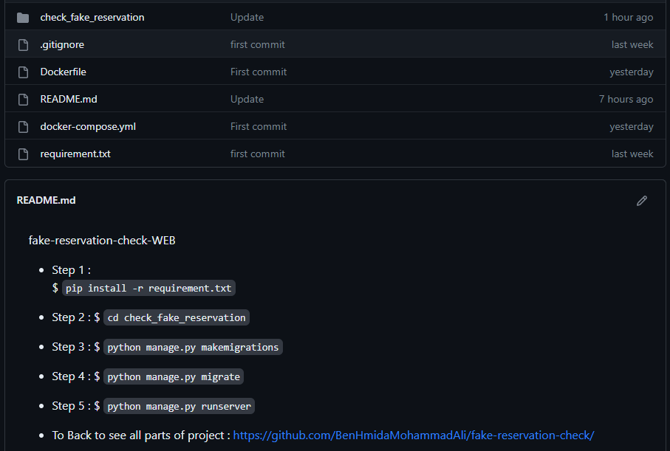

Figure 11 Screenshot of web and deployement Project repository named “Fake-reservation-check-WEB“

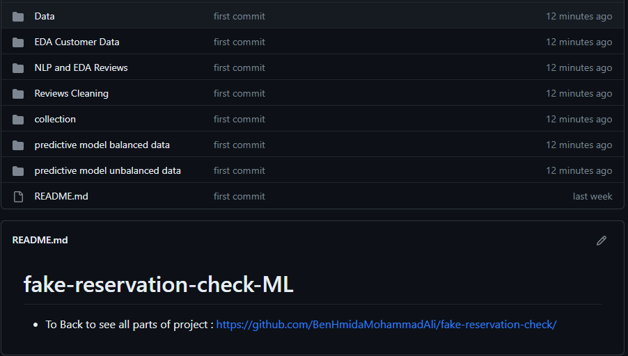

Figure 12 Screenshot of ML Project repository named “Fake-reservation-check-ML“

## 1.7 CRISP-DM for Machine Learning

CRISP-DM (Cross-Industry Standard Process for Data Mining) is a popular methodology for developing machine learning models. It consists of six phases:

Business understanding: In this phase, the problem to be solved is defined and the project objectives are established.

Data understanding: In this phase, the data is collected and analyzed to identify patterns, trends, and potential issues.

Data preparation: In this phase, the data is cleaned, transformed, and organized to prepare it for analysis.

Modeling: In this phase, the machine learning model is selected and trained on the data.

Evaluation: In this phase, the model is evaluated on a new dataset to assess its performance and identify areas for improvement.

Deployment: In this phase, the model is integrated into a production environment and made available for use.

## 1.8 Conclusion

In this chapter, we introduced the background and objectives of the project, as well as the problem statement and definitions of machine learning and Business Intelligence. We also discussed the importance of web scraping and data sources in collecting data for the project. In the next chapter, we will discuss the methodology used in this project, including the steps taken to collect, clean, and analyze the data.

# Chapter 2: Business Intelligence (BI)

## 2.1 Definition and Quick Differentiation of BI

Business Intelligence (BI) refers to the tools, techniques, and applications used to collect, integrate, analyze, and present business data. BI solutions are designed to help organizations make data-driven decisions and gain actionable insights into their operations. The primary objective of BI is to provide business users with timely and accurate information that can help them make informed decisions.

The BI process consists of several steps, including data collection, data integration, data analysis, and data presentation. Each step in the BI process requires specialized skills and tools to ensure that the data is accurate, consistent, and useful to decision-makers.

## 2.2 Data Source

The first step in the BI process is data collection, which involves gathering data from various sources and storing it in a centralized location. In this project, we used two different data sources: Kaggle and British flight reviews.

The Kaggle dataset contained information on airline passenger satisfaction ratings, including attributes such as in-flight service, check-in, onboard experience, and arrival and departure procedures. This dataset was collected from various airlines worldwide, including major and low-cost carriers.

The second data source was British flight reviews, which we obtained by web scraping online review websites. This dataset contained detailed information on flight routes, flight numbers, flight durations, flight frequencies, and flight ratings.

Both datasets were collected in Excel format, and we used Excel to store and manipulate the data before importing it into our data warehouse.

**Website from where we scrapped our data**:

<https://www.airlinequality.com/airline-reviews/british-airways/page/1/?sortby=post_date%3ADesc&pagesize=100>

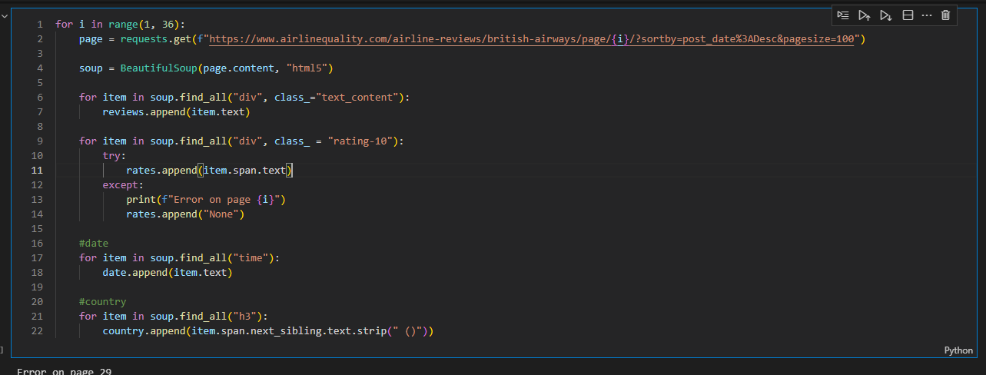

Figure 13 Screenshot of part of Web Scraping Code

## 2.3 Data Preparation

Data preparation involves transforming raw data into a format suitable for analysis. This process typically includes data cleaning, data integration, and data transformation.

In our project, we performed several data preparation tasks, including:

Data cleaning: We removed any duplicates, missing values, or irrelevant data from our datasets.

Data integration: We merged the two datasets using a common key, which was the flight route.

Data transformation: We converted the data into a format suitable for our data warehouse and BI tools. (Set values with type string and object to values of type integer)

## 2.4 Creating Database Objects

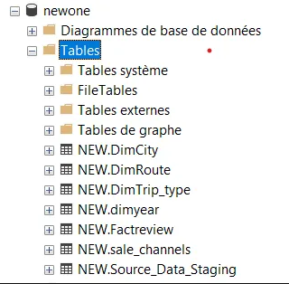After the data preparation phase, we created the necessary database objects for our data warehouse. This involved designing the schema, creating tables, and defining relationships between them using **SQL Server data Tools**.

Figure 14 Screenshot of newone database

### 2.4.1 ETL Source to Staging

We then used ETL (extract, transform, load) processes to transfer the data from the source systems to the staging area of our data warehouse. This involved extracting the data from the Excel files, transforming it to fit the data warehouse schema, and loading it into the staging area.

Excel File

Staging Database

Figure 15 Graph explained ETL Source to Staging

In this step we created in database the staging table as the next figure.

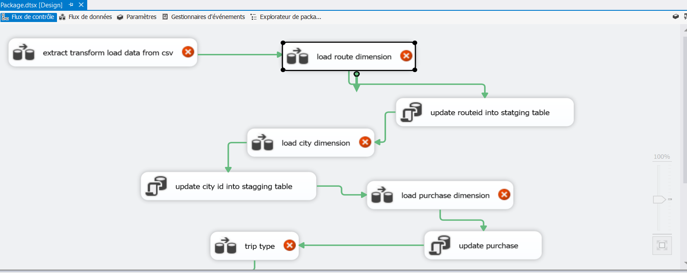

Figure 16 Screenshot of the flow of charging from csv file to staging table

### 2.4.2 ETL Staging to DW

Next, we used ETL processes to move the data from the staging area to the data warehouse proper. This involved extracting the data from the staging area, transforming it further if necessary, and loading it into the appropriate tables in the data warehouse.

Figure 18 Graph explained ETL staging to Datawarehouse

Staging Database

Datawarehouse

In this step we created in data warehouse the dim and fact tables as the next figure.



Figure 19 Screenshot of the flow of charging from staging table to Data warehouse 1

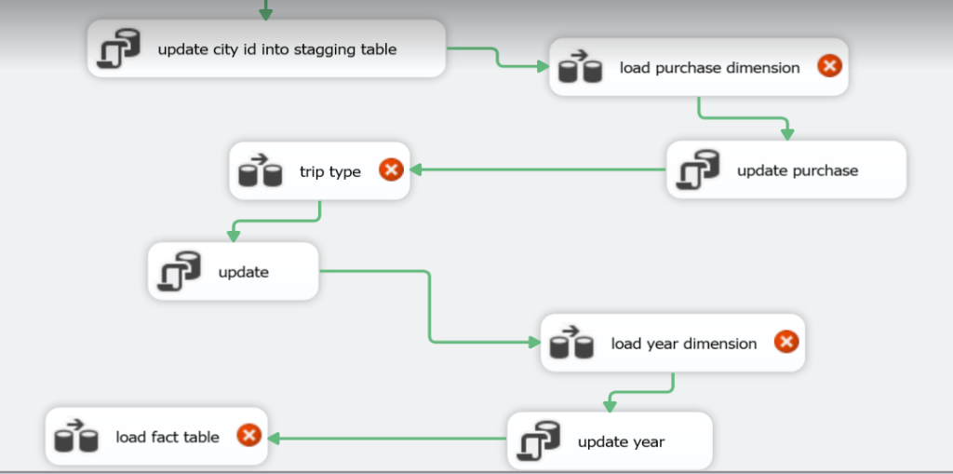

Figure 20 Screenshot of the flow of charging from staging table to Data warehouse 2

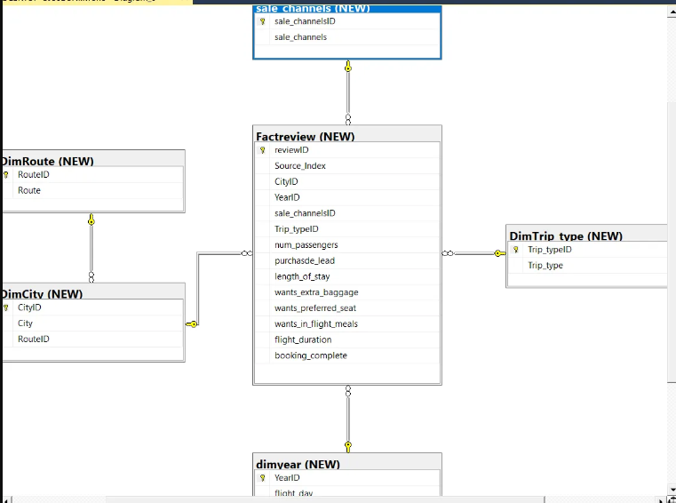

Figure 21 Screenshot of the data warehouse

## 2.5 Semantic Layer

The semantic layer is a layer of abstraction between the physical data model and the business user. It’s implemented using **SQL Server Integration Services** (SSIS) for Tabular and Multidimensional and **SQL Server Management Studio** (SSMS) to creating the Cube.

### 2.5.1 SSIS Tabular and Multidimensional

SSIS is a Business Intelligence tool from Microsoft that provides OLAP (Online Analytical Processing) and Data Mining functionality for business users. It has two main modes: Tabular and Multidimensional. In the Tabular mode, the data model is created using a relational model and is optimized for in-memory processing. In the Multidimensional mode, the data model is created using a dimensional model and is optimized for disk-based processing.

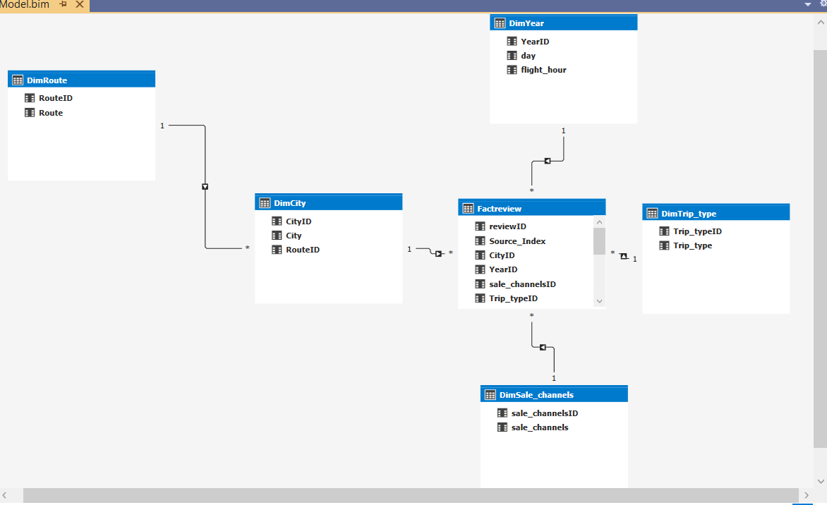

Figure 23 Screenshot of Tabular project using SSIS

### 2.5.1 SSMS Cube

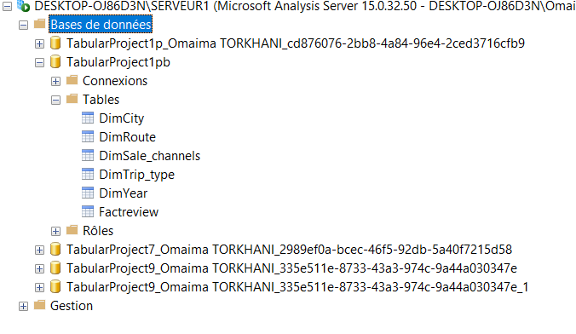SSMS Cube, or SQL Server Management Studio Cube, refers to a multidimensional data structure created and managed within SQL Server Management Studio. It allows for efficient storage, analysis, and reporting of multidimensional data by organizing and aggregating information along multiple dimensions.

Figure 24 Screenshot of Cube using SSMS

## 2.6 Creating Power BI Report

Power BI is a business analytics tool from Microsoft that provides interactive visualizations and business intelligence capabilities with an interface simple enough for end users to create their own reports and dashboards. Creating a Power BI report involves connecting to the data source, selecting the appropriate data elements, and designing the report layout. Power BI provides a range of visualizations, including charts, tables, and maps, that can be customized to meet the needs of the user.

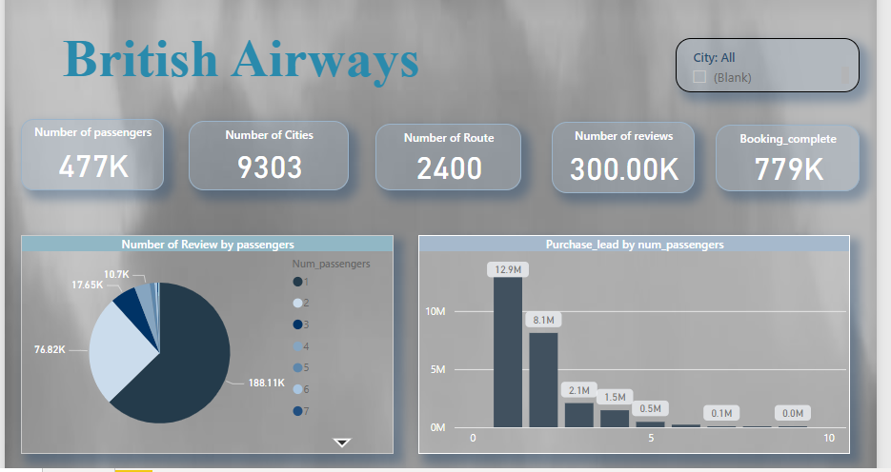

Figure 25 Screenshot of Power BI report 1

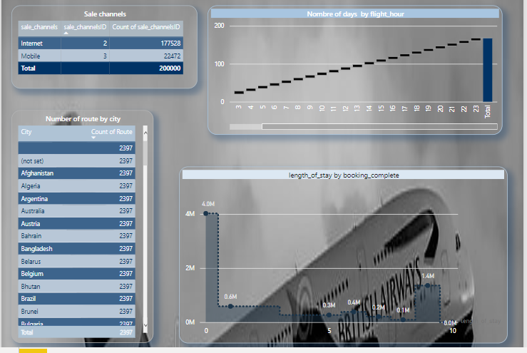

Figure 26 Screenshot of Power BI report 2

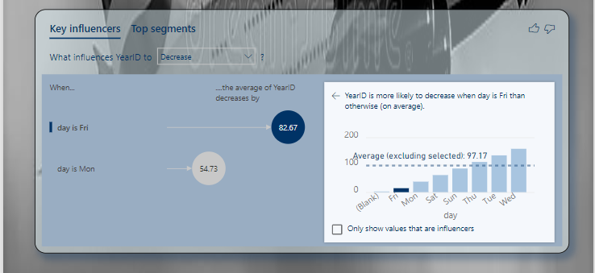

Figure 27 Screenshot of Power BI report 3

## 2.7 Conclusion

In conclusion, Business Intelligence is a critical process that enables organizations to transform data into actionable insights. It involves a range of activities, including data source identification, data preparation, semantic layer development, report authoring, and presentation. Effective Business Intelligence requires a collaborative effort between the Business Intelligence team and the business stakeholders to ensure that the solution meets the needs of the business. In the next chapter, we will discuss the Data Mining process, which is a key component of Business Intelligence.

# Chapter 3: Machine learning (ML)

## 3.1 Definition and Quick Differentiation of ML

Machine learning is a subfield of artificial intelligence that focuses on the development of algorithms and statistical models that enable computer systems to improve their performance on a specific task by learning from data, without being explicitly programmed. The process of machine learning involves feeding a large amount of data to a model, which learns from the data and improves its performance over time.

## 3.2 Steps for Developing a Machine Learning Model

As we told in first chapter we will use CRISP-DM as method to develop the machine learning model with those steps:

### 3.2.1 Business understanding

In this phase, the problem to be solved is defined the fake reservations that passengers created for reasons of scams. In this project we had as objectives to create a model using Machine learning algorithm which is based on the dataset to predict the frauds reservations.

### 3.2.2 Data understanding

In this phase, the data is collected and analyzed to identify patterns, trends, and potential issues. As we are already saw in the previous chapter using BI presentations to know the meaning of features.

In this table (**Table1**) we will know more about meaning of each column in our dataset.

Table 1 Table of meaning of columns

|  |  |
| --- | --- |
| Column name | Description |
| num_passengers | number of passengers travelling |
| sales_channel | sales channel booking was made on |
| trip_type | trip Type (Round Trip, One Way, Circle Trip) |
| purchase_lead | number of days between travel date and booking date |
| length_of_stay | number of days spent at destination |
| flight_hour | hour of flight departure |
| flight_day | day of week of flight departure |
| route | origin -> destination flight route |
| booking_origin | country from where booking was made |
| wants_extra_baggage | if the customer wanted extra baggage in the booking |
| wants_preferred_seat | if the customer wanted a preferred seat in the booking |
| wants_in_flight_meals | if the customer wanted in-flight meals in the booking |
| flight_duration | total duration of flight (in hours) |
| booking_complete | flag indicating if the customer completed the booking |

Table 2 Divide the columns into features and labels

|  |  |
| --- | --- |
| Features | Label (Target) |
| num_passengers, sales_channel, trip_type,  purchase_lead, length_of_stay,flight_hour, flight_day, route, booking_origin, wants_extra_baggage, wants_preferred_seat, wants_in_flight_meals,flight_duration | booking_complete |

3.2.3 Data preparation

In this phase, the data is cleaned, transformed, and organized to prepare it for analysis.

We will follow these 9 steps:

1. 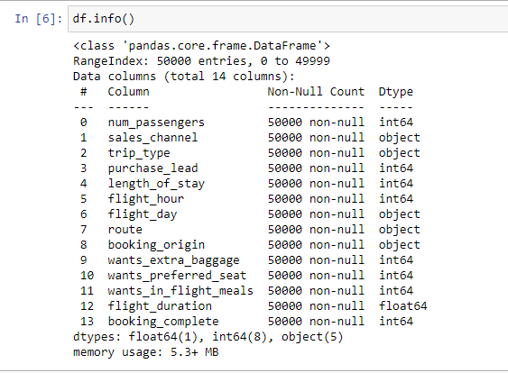See more details about our feature

Figure 28 Screenshot of dataset details

1. Encoder categorical columns

- For **sales_channel**: if value is Internet so 0 and if value is Mobile so 1

- For **trip_type** if value is RoundTRip so 0, if value is OneWayTrip so 1 and if CircleTrip so 2

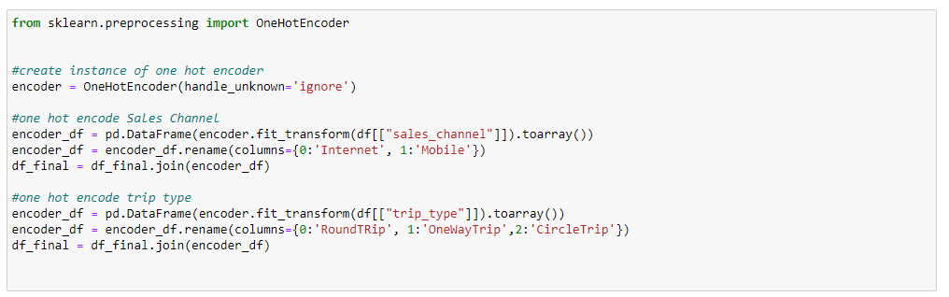

Figure 29 Code of Encoder function

1. Delete categorical columns



Figure 30 Code of drop categorical columns

1. Create Label dataframe



Figure 31 Code of Creating Label dataframe

1. Delete Label column from features dataframe



Figure 32 Code of deleting Label from features dataframe

1. Normalizing the values

Normalizing the values in a dataset is a common preprocessing step in machine learning. It involves scaling the values of the features to a standard range, usually between 0 and 1 or -1 and 1, to ensure that they are on a similar scale

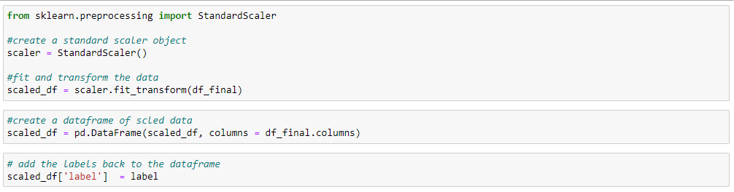

Figure 33 Code of Normalizing the values

1. Correlation matrix

A correlation matrix is a table that shows the correlation coefficients between variables in a dataset. The coefficients range from -1 to 1 and indicate the strength and direction of the relationship between variables.

1 indicates a strong positive correlation.

0 indicates no correlation.

-1 indicates a strong negative correlation.

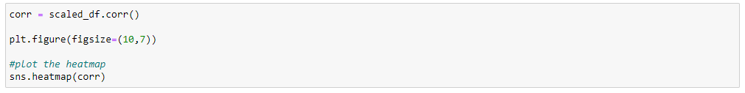By examining the matrix, you can quickly identify patterns and relationships between variables.

Figure 34 Code to create the correlation matrix

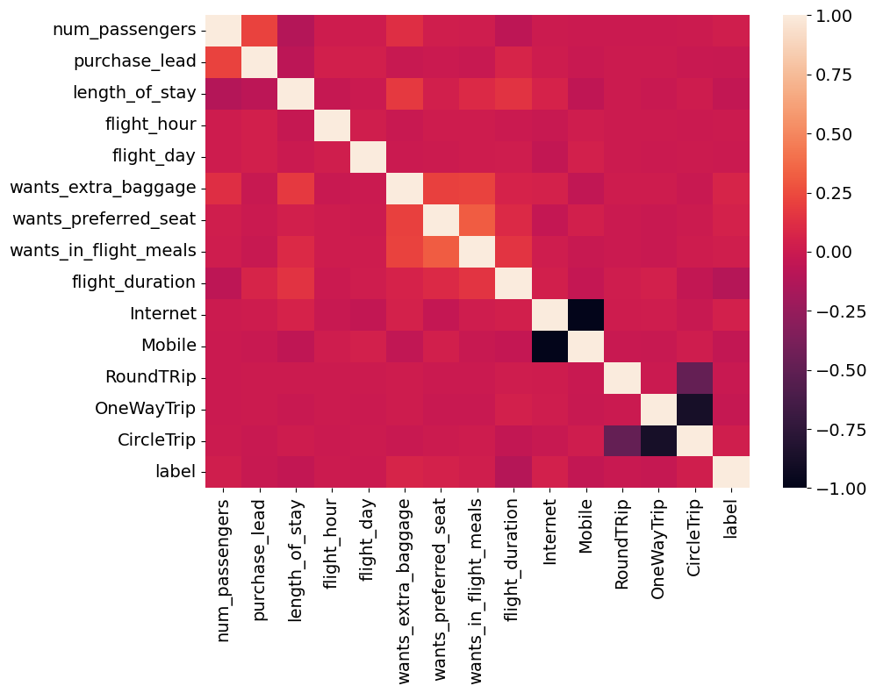

Figure 35 figure of correlation matrix

### 3.2.4 Modeling

In this phase, the machine learning model is selected and trained on the data.

1. Splitting Train and Test Data

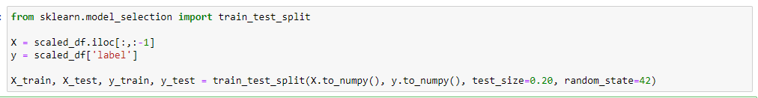

Figure 36 Code of spliting data into test and train data

1. Model creation

(In this part we are already try other models to use but when we evaluated We find that this model had best scores).

In this step we will create an instance of the classifier and fit the training data. We choose **Random Forest Classifier** algorithm

We choose this algorithm for:

Accuracy: It delivers high accuracy in predicting outcomes for both classification and regression tasks.

Feature importance: It provides a measure of feature importance, aiding in feature selection and understanding data relationships.

Overfitting reduction: The ensemble nature of Random Forests helps reduce overfitting by averaging predictions.

Scalability: It efficiently handles large datasets and performs well in parallel computing environments.

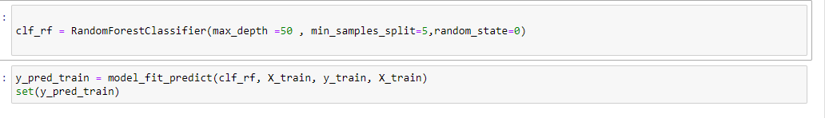

Figure 37 Code of Creation random forest model and the training

### 3.2.5 Evaluation

In this phase, the model is evaluated on a new dataset to assess its performance and identify areas for improvement.

1. Create functions to calculate the accuracy, precision and f1 scores to evaluate the model.

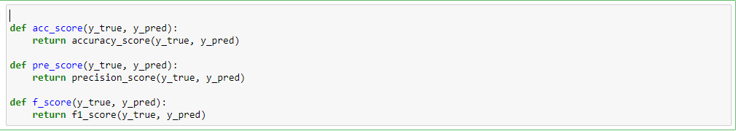

Figure 38 Code of evaluation score functions

1. Test our model

Our model gives us a training test:

Accuracy = 0.93

Precision = 1.0

f1-score =0.72

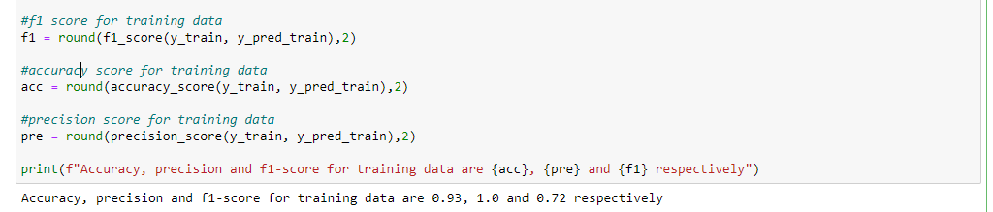

Figure 39 Code of testing and evaluating the model

### 3.2.6 Deployment

In this phase, the model is integrated into a production environment and made available for use. We take the next chapter to show the application that we developed.

## 3.3 Conclusion

To summarize, this chapter outlined the development and evaluation of our Machine Learning (ML) model using the CRISP-DM methodology. By following this structured approach, we successfully addressed the business problem through stages like data collection, preprocessing, model training, and evaluation. The CRISP-DM framework ensured a systematic and well-documented process, resulting in a reliable ML model. The insights gained from this chapter form the basis for the subsequent sections of the report, including discussing the results, limitations, and future improvements of the ML model.

# Chapter 4: Deployment

## 4.1 Definition and Quick Differentiation of ML Deployment

Machine Learning (ML) deployment refers to the process of integrating and running trained ML models in real-world applications or systems to make predictions or decisions based on new input data. It involves taking the model that was developed and trained offline and making it available for practical use. Django, on the other hand, is a popular high-level Python web framework that simplifies the development of web applications. It provides a set of tools and functionalities for building robust and scalable web applications quickly.

## 4.2 Django

Django is a popular Python web framework that simplifies web application development. It provides a set of tools and functionalities that help developers build web applications quickly and efficiently. At its core, Django follows the Model-View-Controller (MVC) architectural pattern, where the "Model" represents the data structure and database schema, the "View" handles the logic for rendering the user interface, and the "Controller" manages the flow of data between the Model and View.

## 4.3 Web Application with Django

In our web application admin can add flights and see reservation of passenger and see their details.

**Figure39** show the project architecture.

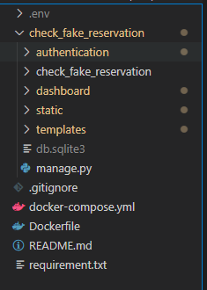

Figure 40 Screenshot of Project Architect

**Figure40** show the login page, if user authenticated as superuser he will get an admin dashboard as **figure41** which in can manage passengers, flights and passenger’s reservations. If user authenticated as simple user he will get a passenger dashboard as **figure42** which can see available flights and reserve one for his trip**.**

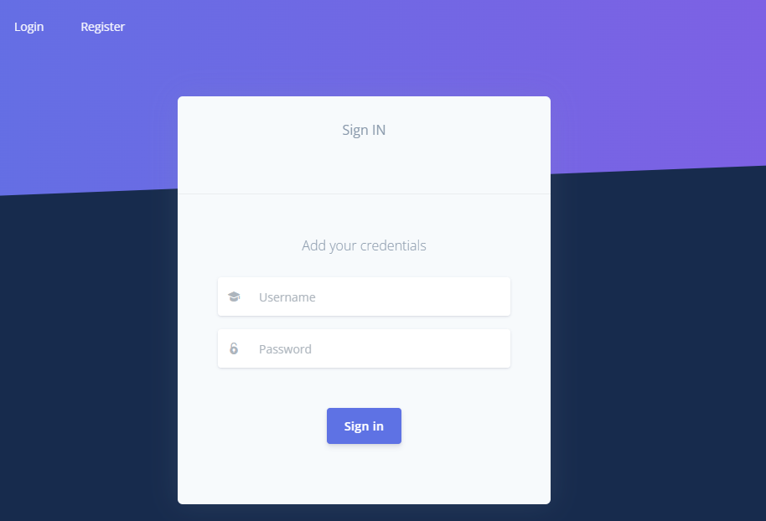

Figure 41 Screenshot of Login Page

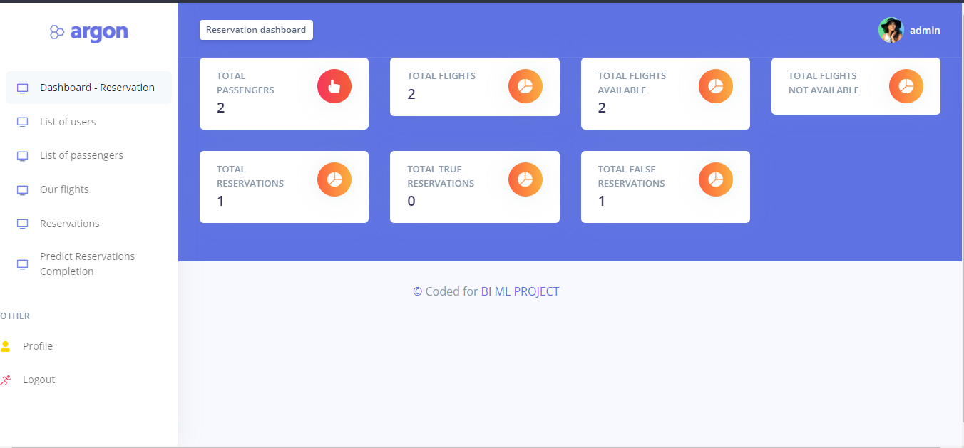

Figure 42 Screenshot of Dashboard Admin Page

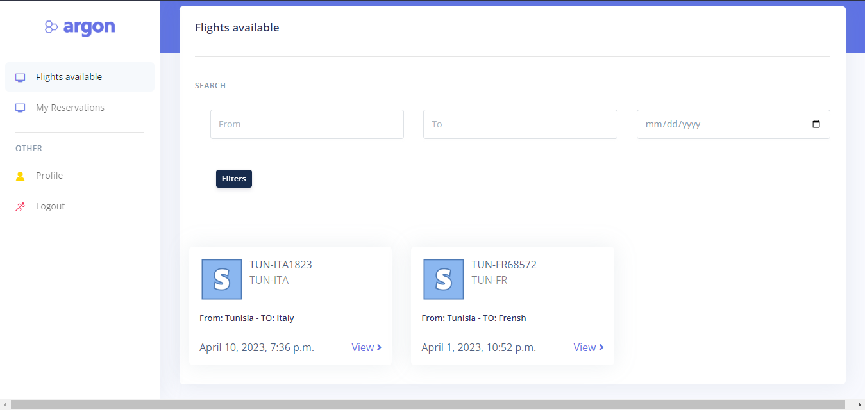

Figure 43 Screenshot of Dashboard simple user Page

## 4.5 ML Model - Deployment

To add the ML model in our application we will add a new folder in our Django project for the trained model.

1. Using pickle to create ml_model.plk and scaler.plk

Pickle: To save and load a saved model from a Pickle file, all you need to do is pass the “pickled” model into the Pickle load () function and it will be deserialized.

After we training models and choosing the best one with most score evaluation, we create “ml_model.plk” to save our model and use it on our web application and “scaler.plk” to save model to normalize the values.

Figure 44 Code using pickle module to creation our ml_model.plk



Figure 45 Code using pickle module to creation our scaler.plk

ml_model.plk and scaler.plk file will be created in our project

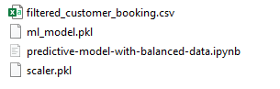

Figure 46 Screenshop of the new files created

1. Create new folder for model method

* 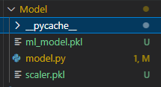Create folder model that had sav file and model.py that’s in we will create the predict function using the model

Figure 47 Screenshot of the Model folder architect

* In model.py we will create a function that get in parameter the features and return the predicted values

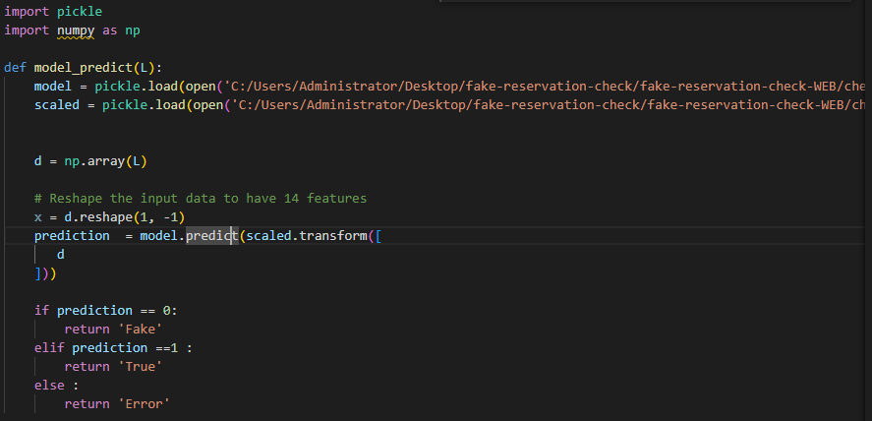

Figure 48 Code of model predict function

* In view function of predict button we will update list of reservation depend of the return value of model predict function.

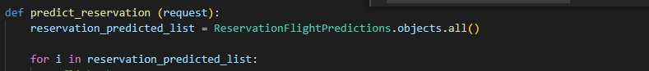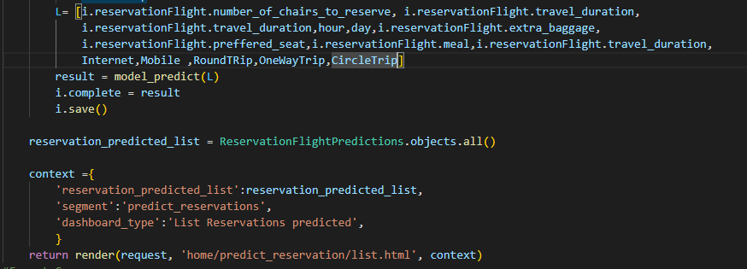

Figure 49 Code of view function predict_reservation code

1. For the first step our Django application show us the list of reservations with state “Pending Model Application”

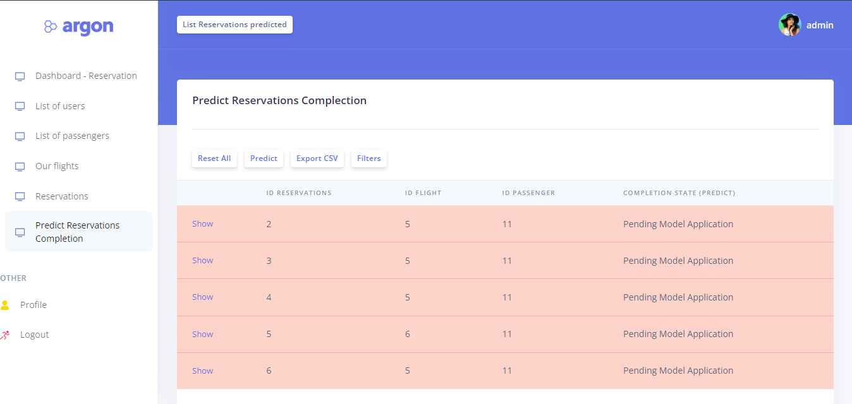

Figure 50 Screenshot of a list of reservations awaiting the application of the model.

1. For the next step our if we clicked on “predict” button the application will predict list of reservation based on our trained model.

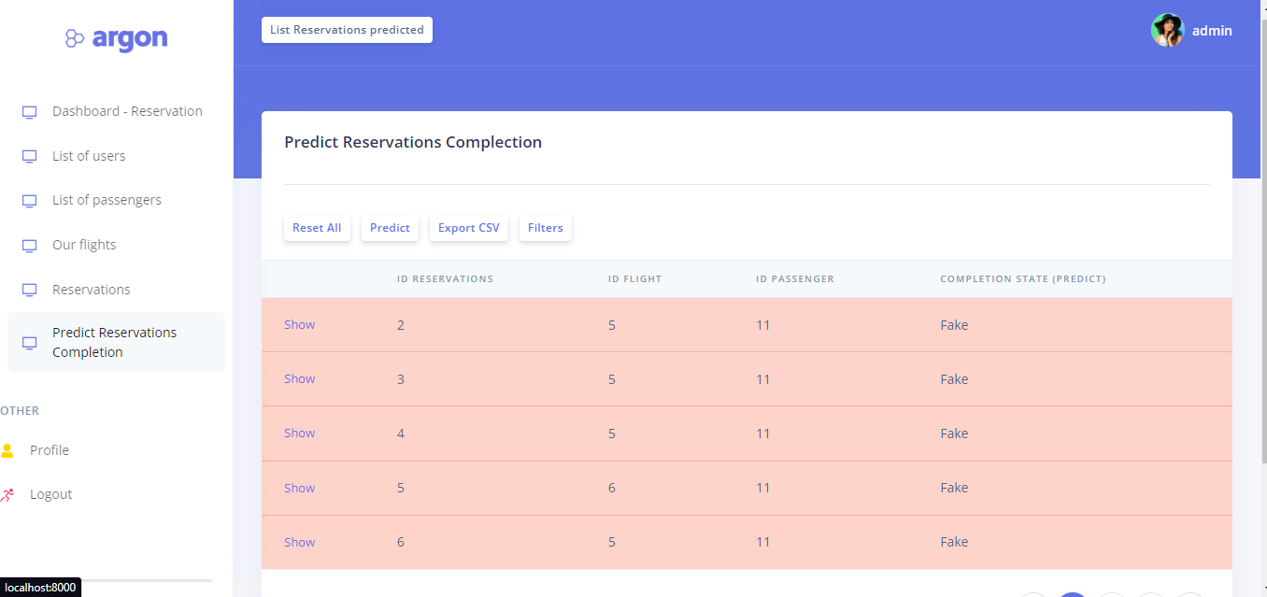

Figure 51 Screenshot of a list of reservations after the application of the model

1. If the “Export CSV” button is clicked, the application will Create a new csv file that had all the data of predictions



Figure 52 List of prediction with export csv button

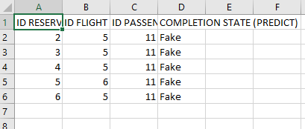

Figure 53 List of prediction in csv file

1. If the “Reset” button is clicked, the application will set the prediction state to " Pending Model Application " to allow the model to be reused for predicting reservations.

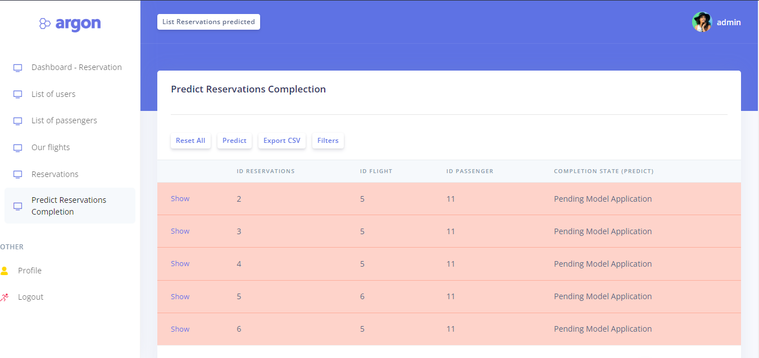

Figure 54 Screenshot of a list of reservations after reset the states

## 4.6 Conclusion

In summary, deploying the machine learning model to an application is important for accessibility, integration, real-time insights and business intelligence. It allows users to seamlessly interact with the tools and take advantage of their functionality within the application environment.

# Conclusion

In conclusion, our project aimed to address the issue of fake reservations in the airline industry using Business Intelligence and machine learning techniques. By analyzing data from British Airways' reservation system, we developed a predictive model to identify fraudulent reservations. Through effective data collection, cleaning, and analysis, we were able to gather insights from multiple sources, including Kaggle and web scraping. The utilization of SSAS Tabular and Power BI reports facilitated interactive data exploration and visualization. The Random Forest Classifier was selected for its accuracy, robustness to noise and outliers, feature importance analysis, and scalability. This model proved effective in predicting the likelihood of fraudulent reservations. By deploying the developed model and Power BI reports within a web application, we enhanced accessibility and user interaction, improving the overall reservation system's security and customer experience. Our project contributes to the airline industry by providing a reliable solution for detecting and eliminating fraudulent activities. Implementing our recommendations can help airlines enhance their reservation systems, build customer trust, and improve fraud detection capabilities. Future work could involve exploring other machine learning algorithms, refining data collection processes, incorporating real-time data feeds, and collaborating with industry stakeholders to implement fraud detection systems on a larger scale. Overall, our project showcases the power of Business Intelligence and machine learning in addressing critical challenges in the airline industry, emphasizing the importance of data-driven decision-making and continuous improvement in fraud detection and prevention.